Zigbee2MQTT Migration Guide

Sonoff Dongle-E v2 → Sonoff Dongle-M (EFR32MG24 / Ember)

No device re-pairing required

🧰 What You Will Need

Hardware
- Raspberry Pi 4 running Home Assistant
- Sonoff Zigbee Dongle‑E v2 (current coordinator)
- Sonoff Zigbee Dongle‑M (new coordinator)
- USB extension cable (strongly recommended to reduce interference)

Software
- Home Assistant (latest)
- Zigbee2MQTT (latest)

⚠️ Critical Rules (Read Before Starting)
- ❌ Do NOT delete Zigbee2MQTT
- ❌ Do NOT create a new Zigbee network
- ❌ Do NOT re-pair any devices
- ❌ Do NOT change PAN ID, Extended PAN ID, network key, or channel
- ✅ We are only replacing the coordinator hardware
If these rules are followed, all devices will automatically reconnect.

Step 1: Back Up Zigbee2MQTT (MANDATORY)
This backup preserves:
- Network keys
- PAN ID / Extended PAN ID
- Device IEEE addresses
- Routing information
Without this backup, re-pairing will be required.

✅ Method 1 (RECOMMENDED): Zigbee2MQTT UI Backup
This is the simplest and safest method.
- Open the Zigbee2MQTT UI
- Click Settings
- Click Tools
- Click Request Z2M backup
- Wait a few seconds
- Click Download Zigbee2MQTT backup
- Save the file to your local computer
✔ This single file contains:
- database.db
- coordinator_backup.json
- configuration.yaml
- All Zigbee network state
📌 This file alone is sufficient for a full restore.

(Optional) Alternative Backup Methods
File Editor
- Backup /config/zigbee2mqtt/
SSH
cp -r /config/zigbee2mqtt /config/zigbee2mqtt_backup

Step 2: Stop Zigbee2MQTT
- Home Assistant → Settings → Add-ons → Zigbee2MQTT
- Click Stop
- Wait until the add-on status shows Stopped

Step 3: Shut Down Home Assistant
- Go to Settings → System → Power
- Click Shut Down
- Wait until the Raspberry Pi fully powers off

Step 4: Physically Swap the Dongles
- Remove Sonoff Dongle-E v2
- Insert Sonoff Dongle-M
- Use a USB extension cable
- Power the Raspberry Pi back on
- Wait for Home Assistant to fully boot

Step 5: Identify the New Serial Port (Correct & Safe Methods)
You must use a persistent /dev/serial/by-id/ path.
❌ Never use /dev/ttyUSB0
✅ Always use /dev/serial/by-id/...

Method 1: Zigbee2MQTT Log
- Home Assistant → Settings → Add-ons → Zigbee2MQTT
- Click Log
- Look for a line similar to:
/dev/serial/by-id/usb-SONOFF_SONOFF_Dongle_Max_MG24_da00da6b6bfaef11b2888d256d9880ab-if00-port0

Copy this entire path.

Method 2: SSH (Very Reliable)
- Open Terminal & SSH
- Run:
ls -l /dev/serial/by-id/

- Copy the left-hand path:
/dev/serial/by-id/usb-SONOFF_SONOFF_Dongle_Max_MG24_da00da6b6bfaef11b2888d256d9880ab-if00-port0

Method 3: Home Assistant Hardware Page (GUI-Only)
- Home Assistant → Settings → Hardware
- Click All Hardware
- Scroll to the Sonoff Zigbee dongle
- Click it to expand
- Copy the device ID / path shown
✔ Home Assistant automatically provides the stable by-id path
✔ /dev/ttyUSB0 is excluded by design
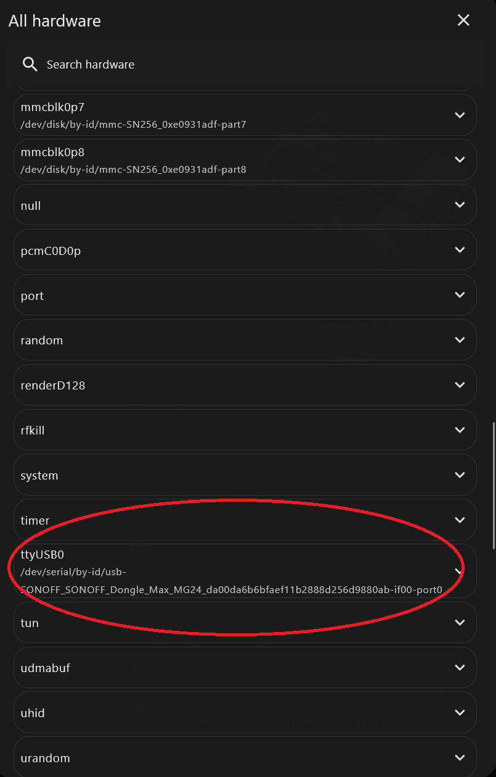

Step 6: Update Zigbee2MQTT Configuration
- Home Assistant → Settings → Add-ons → Zigbee2MQTT
- Click Configuration
- Click Serial twisty
- Under the serial → port, enter the new serial port you copied in step 5: /dev/serial/by-id/usb-SONOFF_SONOFF_Dongle_Max_MG24_da00da6b6bfaef11b2888d256d9880ab-if00-port0
- Click Save

✅ Correct Configuration for Sonoff Dongle-M (EFR32MG24)
serial:
port: /dev/serial/by-id/usb-SONOFF_SONOFF_Dongle_Max_MG24_da00da6b6bfaef11b2888d256d9880ab-if00-port0
adapter: ember
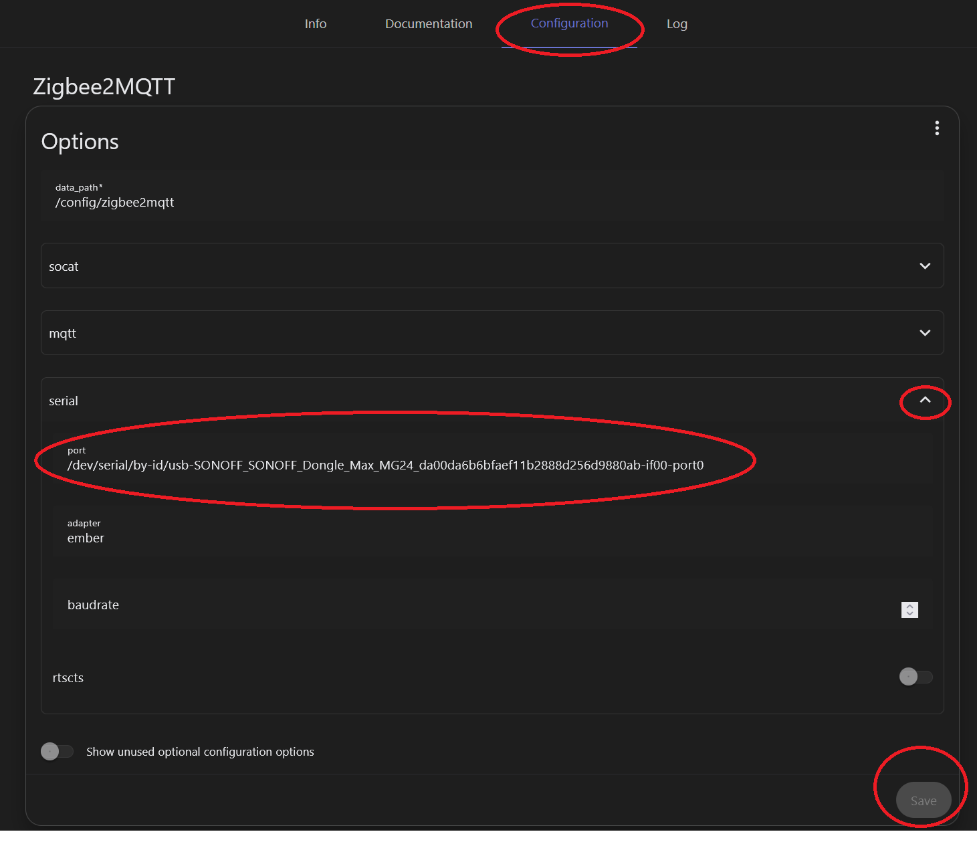
⚠️ Do NOT change:
- pan_id
- ext_pan_id
- network_key
- channel

Step 7: Start Zigbee2MQTT
- Go to Settings → Add-ons → Zigbee2MQTT
- Click Start
- Monitor the logs

Expected Log Lines
Using Ember adapter
Coordinator started
Zigbee network started

- Routers reconnect first
- Battery devices reconnect when they wake
- No pairing mode required

Step 8: Verify Operation

Zigbee2MQTT UI
- Devices show online
- “Last seen” timestamps update

Home Assistant
- All entities unchanged
- Automations continue working

Step 9: Optional Network Optimisation
After 12–24 hours:
- Power-cycle mains-powered routers (plugs, bulbs)
- Leave battery devices untouched
- Allow routing tables to stabilise naturally

🛑 Restore Procedure (If Needed)
- Stop Zigbee2MQTT
- Open Zigbee2MQTT UI → Settings → Tools
- Click Restore Zigbee2MQTT backup
- Upload the previously downloaded backup file
- Reinsert the original dongle if required
- Start Zigbee2MQTT
Your Zigbee network will be fully restored.

✅ Final Result
- Same Zigbee network
- Same devices & entities
- Same automations
- No re-pairing
- Upgraded, future-proof coordinator (EFR32MG24)

